# Minesweeper Generator

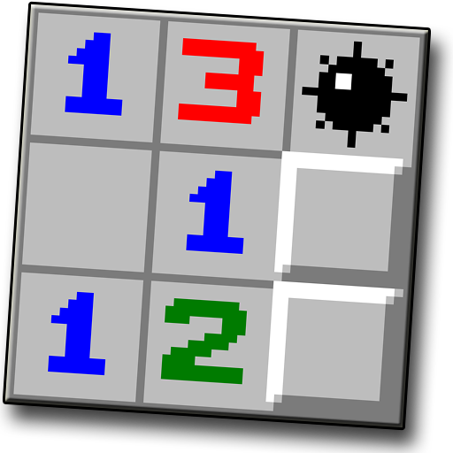

*Everybody remembers the old mines game. Now it is time to create your own.*

You will be given an integer **n** for the **size** of the mines field with **square** shape and another one for the number of bombs that you have to place in the field. On the next **n** lines, you will receive the **position for each bomb**. Your task is to **create the game field** placing the **bombs** at the correct positions and mark them with "**\***", and **calculate the numbers** in each cell of the field. Each **cell** represents a **number** of all **bombs** directly near it (**up, down, left, right and the 4 diagonals**).

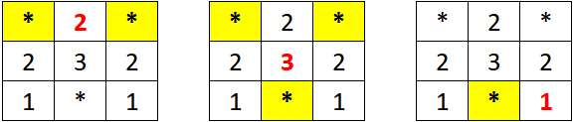

|  |  |
| --- | --- |
| **Input** | **Output** |
| 4  4  (0, 3)  (1, 1)  (2, 2)  (3, 0) | 1 1 2 *  1 * 3 2  2 3 * 1  * 2 1 1 |
| 5  3  (1, 1)  (2, 4)  (4, 1) | 1 1 1 0 0  1 * 1 1 1  1 1 1 1 *  1 1 1 1 1  1 * 1 0 0 |

### Input

* On the first line, you are given the integer **n** – the size of the **square** matrix.
* On the second line – the **number** of the **bombs**.
* The **next n lines** holds the position of each **bomb**.

### Output

* Print the matrix you've created.

### Constraints

* The size of the **square** matrix will be between **[2…15].**

### Examples